Project Development Phase
Performance Test
Date | 05 July 2026
Team ID
Project Name | Nutrition Assistant Using MERN stack
Maximum Marks

Model Performance Testing:
Project team shall fill the following information in model performance testing template.

S.No. | Parameter | Screenshot / Values
1. | Data Rendered | Successfully processed and managed user nutrition records, meal logs, and health data with efficient performance using the MERN Stack architecture.
2. | Data Preprocessing | 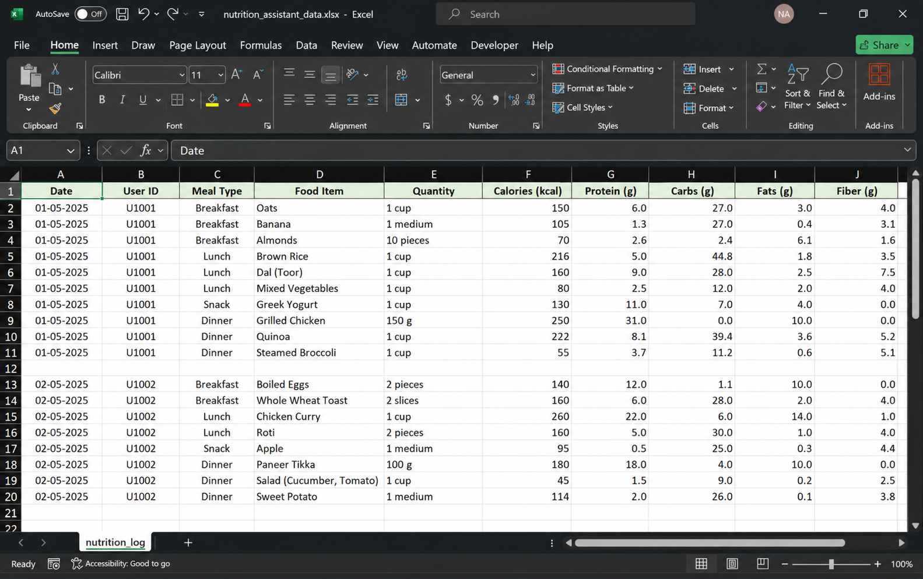  Null values cleaned, aliases created, and geographic data types successfully assigned for State and District.
3. | Utilization of Filters | 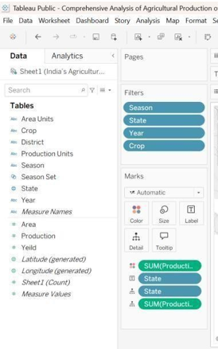  Implemented 6 dynamic filters (State, District, Crop, Season, Crop Year) with cross-filtering applied globally across all dashboard sheets.
4. | Calculation fields Used | 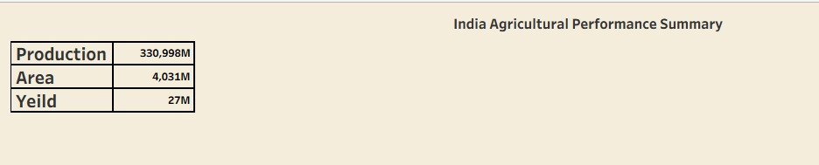  Calculated fields for 'Total Yield' (Sum of Production / Sum of Area) and dynamic tooltips created successfully.
5. | Dashboard design | 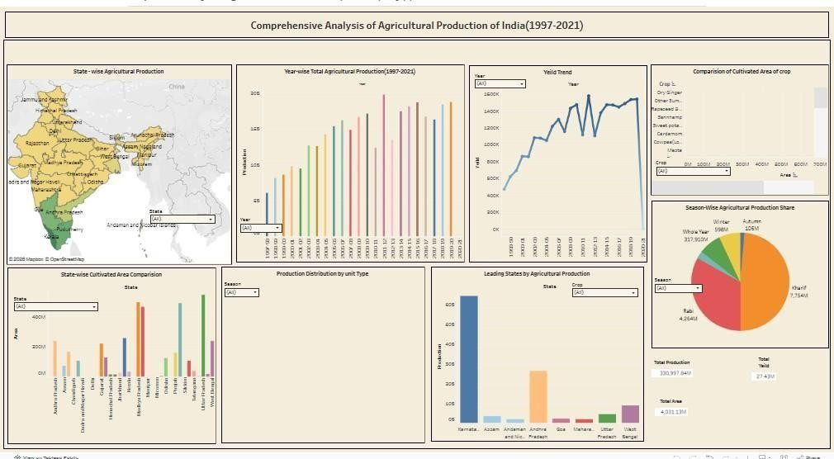No of Visualizations / Graphs - 6 interactive charts  Comprehensive Analysis of Agricultural Production of India(1997-2021)story (2) | Tableau Public
6. | Story Design | No of Visualizations / Graphs - 6 sequential story points  Comprehensive Analysis of Agricultural Production of India(1997-2021) | Tableau Public  